**EXPERIMENT 2**

|  |  |
| --- | --- |
| **Name:** | Keerti P. Charantimath |
| **Roll Number:** | 19MA20059 |

**Part 1 : Ohm’s Law**

1. **Aim of the experiment**
   * To explain Ohm's law, Ohm's law for resistance in series combination and in parallel combination.
   * To confirm ohm’s law for single resistor, series combination and parallel combination of resistors.
2. **Tools used:**

* DC Voltage Source
* Connecting wires
* Resistors
* Ammeter
* Voltmeter

1. **Background knowledge (brief):**
   * The law states that the current through a conductor between two points is directly proportional to the voltage across the two points. Such a conductor is characterized by its ‘Resistance’ – R measured in Ohms.

**V = I×R**

* + V is the Voltage in Volts across the conductor.
  + I is the current in Amperes through the conductor.
  + Ohm's law is valid when temperature is constant.
  + **Explanation:**
    1. **Ohm’s Law for a Single Resistor:**

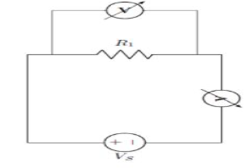

Voltage across the resistor is equal to source voltage, **VR = VS**

The current through the resistor is given by, **I = VR / R**

* + 1. **Ohm’s law for resistance in series:**

Series circuits are sometimes called current-coupled or daisy chain-coupled. The current in a series circuit goes through every component in the circuit. Therefore, all of the components in a series connection carry the same current. There is only one path in a series circuit in which the current can flow.

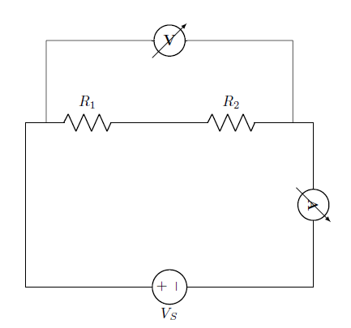

From the circuit,

The equivalent Resistance: Req = R1 +R2

The total current of the circuit: I = VS / Req

Voltage across each resistance are:

VR1 = R1 * It and VR2 = R2 * It

* + 1. **Ohm’s law for resistance in parallel:**

If two or more components are connected in parallel, they have the same potential difference (voltage) across their ends. The potential differences across the components are the same in magnitude, and they also have identical polarities. The same voltage is applicable to all circuit components connected in parallel. The total current is the sum of the currents through the individual components, in accordance with Kirchhoff’s current law.

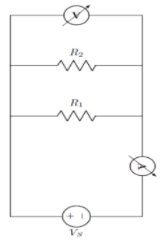

From the circuit,

The equivalent Resistance: Req = (R1 X R2) / (R1 +R2)

The total current of the circuit: I = VS / Req

Current through each resistance are:

IR1 = VS / R1 and IR2 =VS / R2

1. **Circuit (image)**
   * **Ohm’s Law for a Single Resistor:**

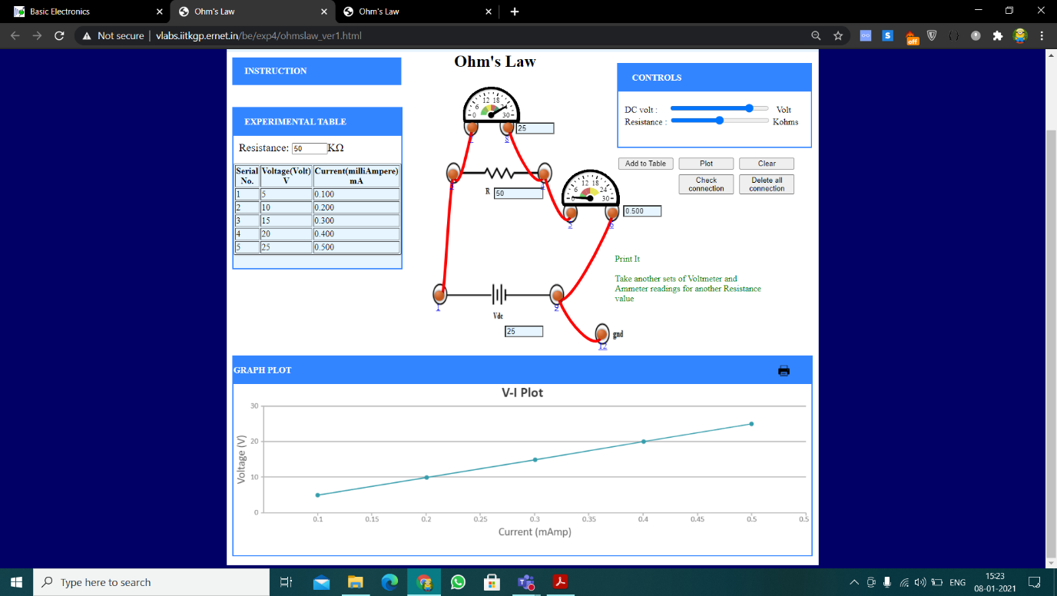

* + **Ohm’s law for resistance in series:**

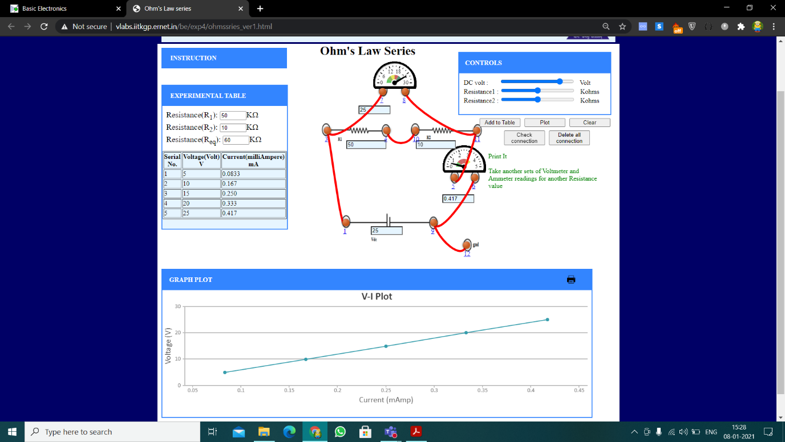

* + **Ohm’s law for resistance in parallel:**

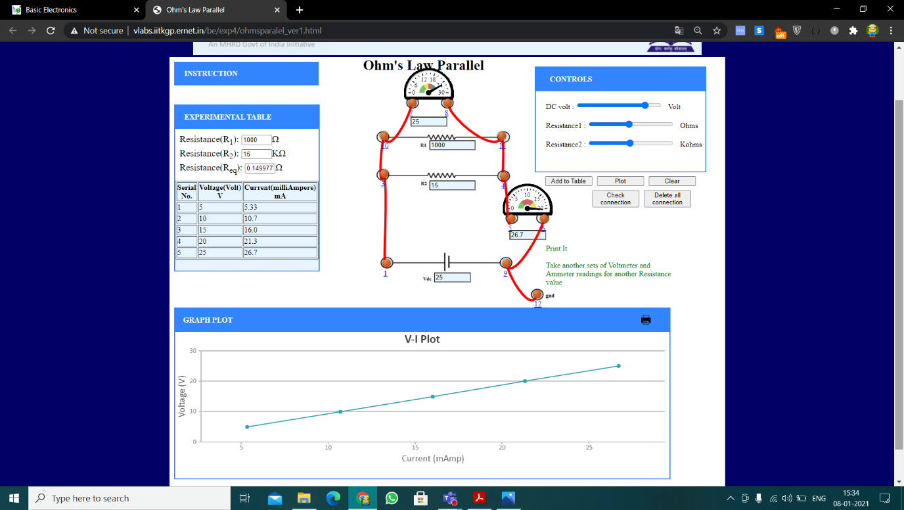

* + **Checking Ohm’s law for non-ohmic device (diode in forward bias):**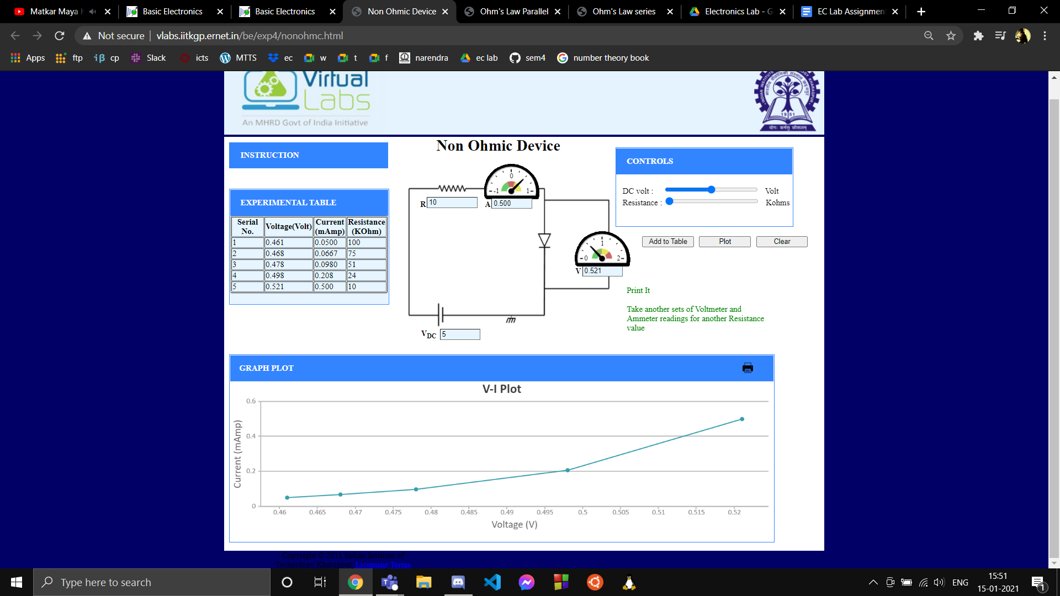

1. **Measurement Data (Tabular form)**
   * **Ohm’s Law for a Single Resistor:**



* + **Ohm’s law for resistance in series:**



* + **Ohm’s law for resistance in parallel:**



* + **Checking Ohm’s law for non-ohmic device(diode in forward bias):**



1. **Graph (Image)/Screenshots**
   * **Ohm’s Law for a Single Resistor:**



* + **Ohm’s law for resistance in series:**



* + **Ohm’s law for resistance in parallel:**



* + **Checking Ohm’s law for non-ohmic device(diode in forward bias):**



1. **Conclusion**
   * The ohm’s law states that current increases in proportion to the potential difference applied. This theory was confirmed from our observation set.
   * Ohm’s law is only valid for linear devices like resistors. As diodes are non-linear circuit elements , we can see that the V-I plot is not linear for them, hence we can conclude that Ohm’s lar is not applicable for such devices.
   * We also observed the slope of the graph is equal to the resistance.
   * We could also confirm the laws of resistance combinations through our observations.
2. **Discussions**
   * Ohm’s law is the fundamental law in the field of electricity. provides the relationship between current, voltage, and resistance. While illustrating it practically, we use a device named voltmeter to measure the voltage across the resistor and ammeter to measure the current passing through it. Accuracy of your result depends on how precisely these instruments measure these values. Now a days, use of multimeter is more common as it’s a multifunctional device which can measure many electrical properties like voltage, current, resistance, capacitance, etc.
   * Ohm's law holds for circuits containing only resistive elements (no capacitances or inductances) for all forms of driving voltage or current, regardless of whether the driving voltage or current is constant (DC) or time-varying such as AC. At any instant of time Ohm's law is valid for such circuits.
   * When two resistors are connected end to end they are said to be connected in series and when connected across each other they are said to be in parallel. Any configuration of any number of resistances can be simplified to a combination of these two types of connections. When resistors are connected in series their equivalent resistance will be greater than the greatest of the component resistances and when connected in parallel the equivalent resistance will be lesser than the least of the component resistances.
   * In a series circuit voltage division takes place : current is same in each resistor, but voltage gets divided between the resistors in direct proportion to their resistances. In a parallel circuit, voltage is same in each resistor, but current gets divided between the resistors in inverse proportion to their resistances

**Part 2 : Diode Current- Voltage Characteristics**

1. **Aim of the experiment:**
   * To obtain V-I Characteristics of forward and reverse bias of silicon-diode
   * To obtain V-I characteristics of forward and reverse bias of Ge-Diode.
2. **Tools used:**

|  |  |  |  |
| --- | --- | --- | --- |
| **Instruments** | **Type** | **Range/Value** | **No. of unit** |
| Voltmeter | MI | 0-2 V | 1 |
| Ammeter | MI | 0-30 mA 0-16 mA | 1  1 |
| Resistance |  | 0-2000 ohms 0-10 K ohms | 1  1 |
| Diodes | Silicon Germanium | 1N4001 - | 1  1 |
| DC Voltage Supply |  | 0-5 V 0.2-30.2 V | 1  1 |

1. **Background knowledge:**
   * A diode formed by junction of p doped and n doped semiconductor is called p-n diode. The p side of diode is the cathode and the n side is anode.
   * **Forward Biasing**

In forward bias the positive terminal of battery is connected to p-side while negative side of battery connected to n-side of p-n junction diode. The depletion region decreases in width, and electrons and holes move towards the junction as they are repelled from negative and positive terminals of the voltage source respectively. Hence the holes and electrons overcome the barrier potential at depletion region and flow across the diode. Therefore a current is generated and a closed circuit is formed.

* + **Reverse Biasing**

In forward bias the negative terminal of battery is connected to p-side while positive side of battery connected to n-side of p-n junction diode. The width of the depletion region increases as the external field supports the field inside the depletion region. In reverse bias case the thermal energy continuously creates a limited number of electrons and holes both sides of junction and creates very small amount of current called saturation current Is and it’s doesn’t depends on applied voltage. The diode does not conduct significant electricity, unless the voltage applied exceeds breakdown voltage. In that case, a huge amount of and almost current suddenly starts flowing through the diode.

* + **Diode V-I Relationship**

The V-I relation of a diode is non- linear. In forward bias, an ideal diode follows an exponential relation called the ideal diode equation.



1. **Circuit (hand drawn/image):**
   * **Forward Bias Silicon Diode (1N4001)**

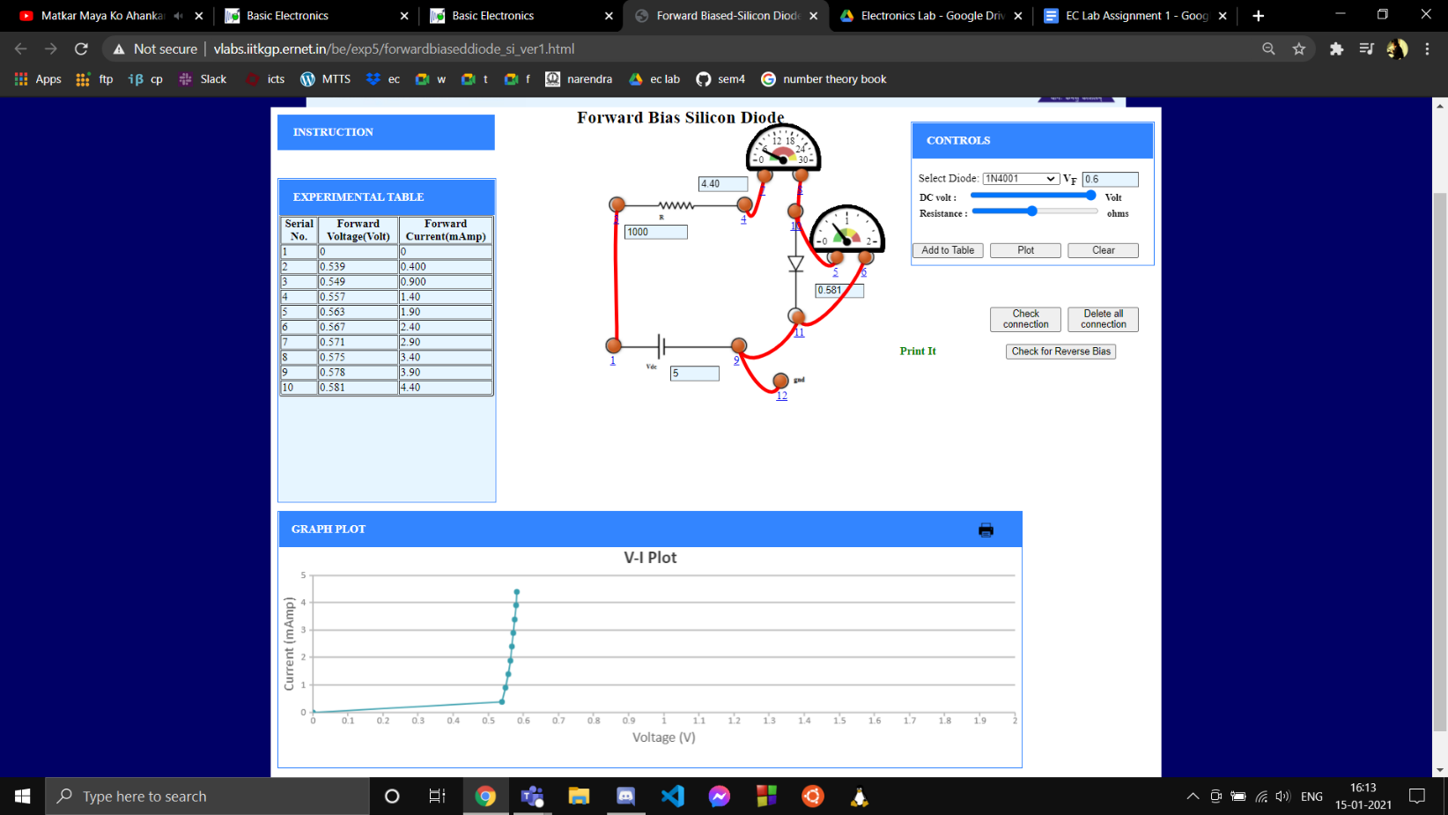

* + **Reverse Bias Silicon Diode (1N4001)**

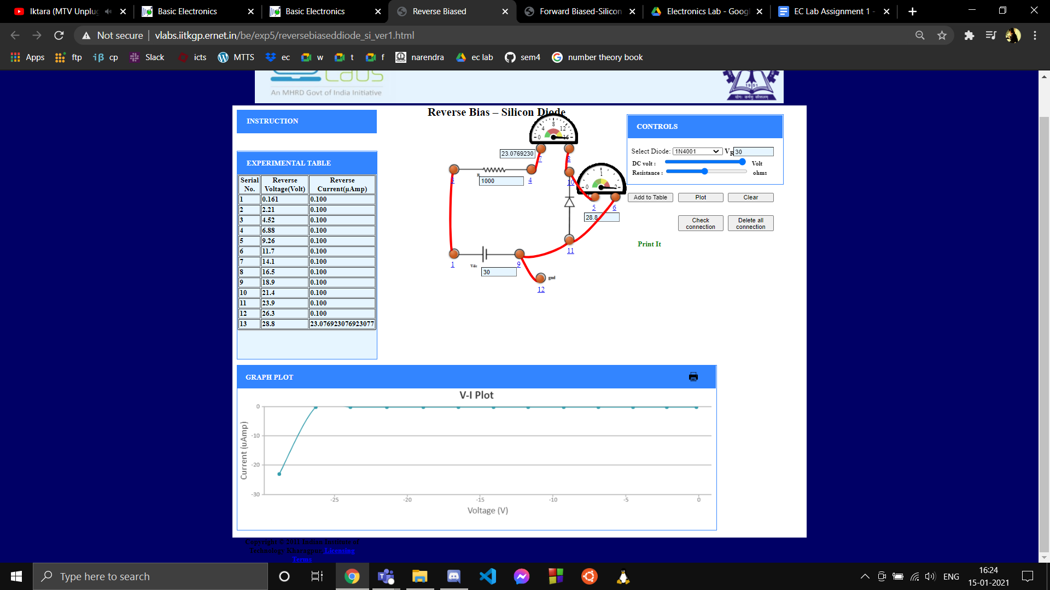

* + **Forward Bias Germanium Diode**

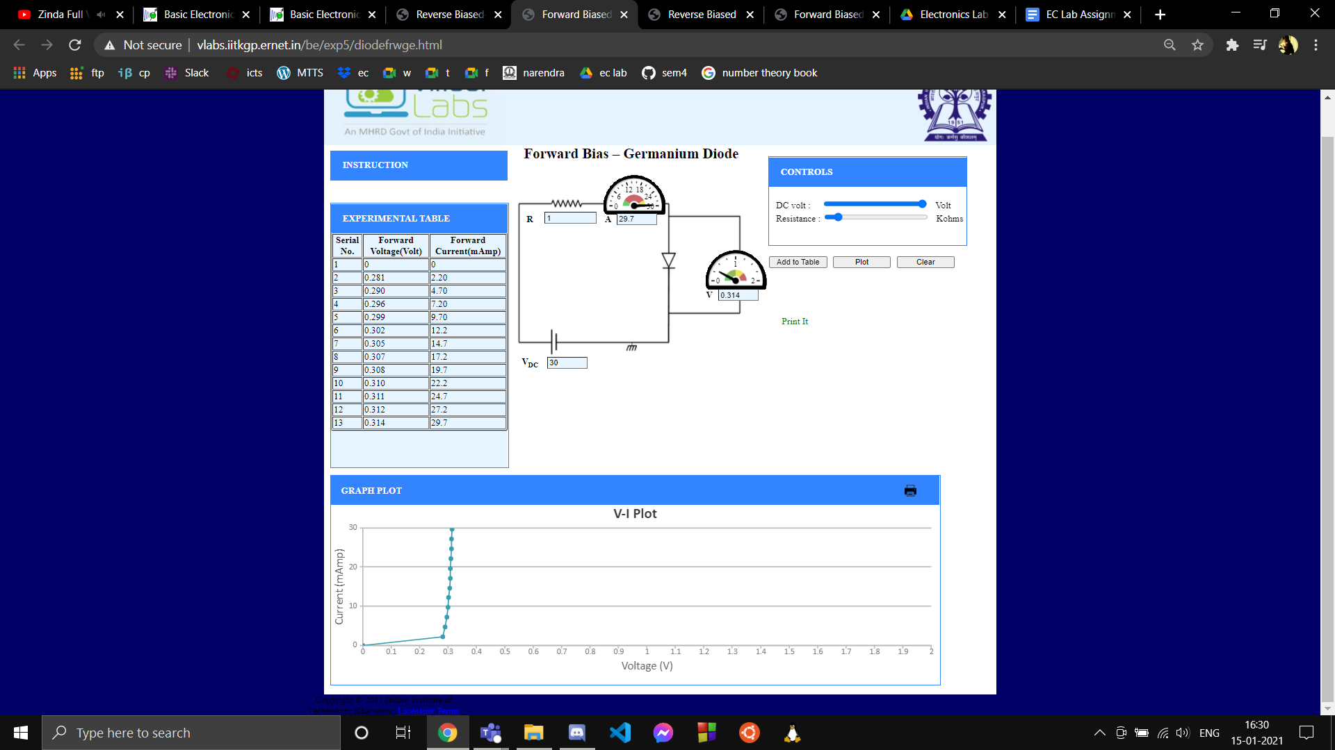

* + **Reverse Bias Germanium Diode**

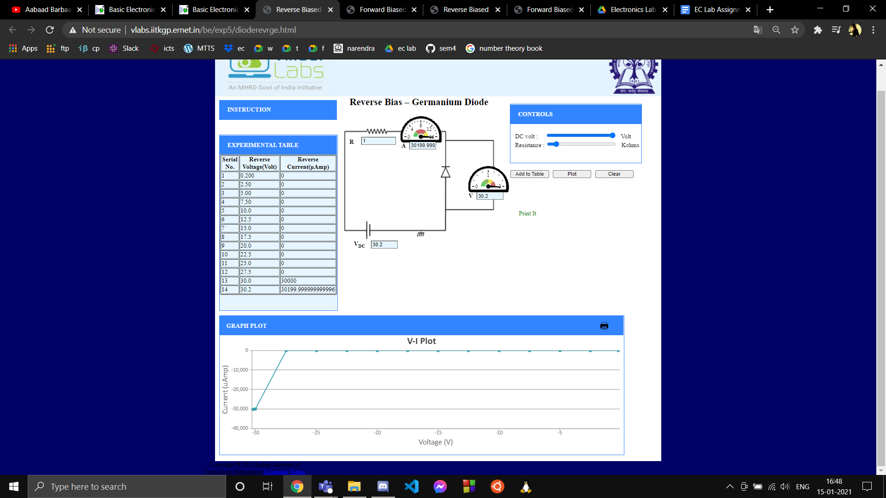

1. **Measurement Data (Tabular form):**
   * **Forward Bias Silicon Diode (1N4001)**

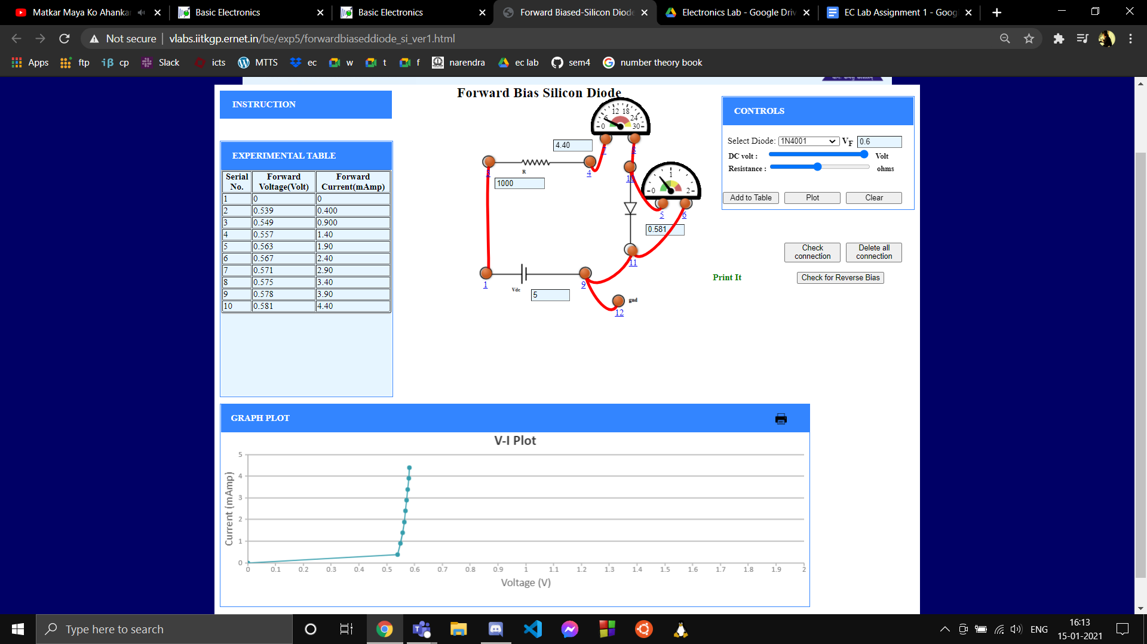

* + **Reverse Bias Silicon Diode (1N4001)**



* + **Forward Bias Germanium Diode**



* + **Reverse Bias Germanium Diode**



1. **Graph (Image/Screenshots)-**
   * **Forward Bias Silicon Diode (1N4001)**



* + **Reverse Bias Silicon Diode (1N4001)**



* + **Forward Bias Germanium Diode**



* + **Reverse Bias Germanium Diode**



1. **Conclusion:**
   * A diode follows nonlinear V-I relation in forward bias. The current increased exponentially with voltage after the Voltage barrier was broken.
   * In the forward-biased 1N4001 Silicon diode the knee voltage is around 0.6V after which the current increases exponentially.
   * In the forward-biased Germanium diode, the knee voltage is 0.3V. The current in the diode is very less before this value, but once forward biasing voltage exceeds this value, current increases exponentially with increase in voltage.
   * For a reverse biased diode, there is almost zero current which flows until the breakdown voltage is reached after which the current through the diode increases tremendously.
   * The silicon diode breaks down at approx. 3V and Germanium Diode breaks down when the reverse potential is around 30V.
   * Hence any Diode can be used as a switch in forward bias region diode act as an “On Switch “ while in reverse bias region diode act as an “off switch “.
2. **Discussions:**
   * We saw during experiment when a reverse bias voltage is applied across a p-n junction diode the holes from p-type region moves away from the junction and the same electron from n-type region moves away from the junction so the depletion layer will increase. The increase. The depletion layer acts as a dielectric medium and two electrodes store the electric charge. Now if we increase applied voltage, the depletion layer will also increase and the size of p and n-region will decrease. Consequently the ability to store electric charge will be reduced the applied voltage is inversely proportional to junction capacitance.
   * In reverse biased of P-N junction, a very small amount of current called reverse saturation current -is able to flow in reverse through the diode. With increase in reverse voltage Is remains very small initially (may be of the order of pA or fA) but at vary large reverse voltage the diode can conduct very heavily with very little increase in reverse voltage and this voltage is called “breakdown voltage”.
   * Each side of the junction contains an excess of holes or electrons compared to the other side, hence there exists a large concentration gradient. Therefore, diffusion current flows across the junction from each side.
   * The band gap for germanium is much lower than it is for silicon. It basically takes less energy (proportional to electric field or voltage) to kick the crystal into conduction. This translates to a lower "cut-in" voltage for Ge when compared to Si.
   * The electric field in the space charge region gives rise to potential barrier...this is known as built in potential. We saw during experiment that in forward bias region “Built-in-potential” decreased as forward voltage increased. And in reverse biased region “Built-in-potential” increased as applied reversed voltage increased.

**Part 3 : RC Frequency and Phase Responses**

1. **Aim of the experiment:**
   * To analyse the frequency and phase response of low pass and high pass electronic filters.
2. **Tools used:** 
   * Capacitors(1.91nF,0.01nF)
   * Resistors(10kOhms)
   * AC 10V source
   * Connecting wires
   * Multimeter
3. **Background knowledge:**
   * Electronic filters are devices that allow or disallow the passage of signals falling in a certain range of frequencies.
   * Low pass filters are constructed by connecting resistor and capacitor in series and taking output voltage across the capacitor.
   * High pass filters are constructed by connecting resistance and capacitor in series and taking output voltage across the resistor.

1. **Circuit (hand drawn/image):**
   * **Low Pass Filter**

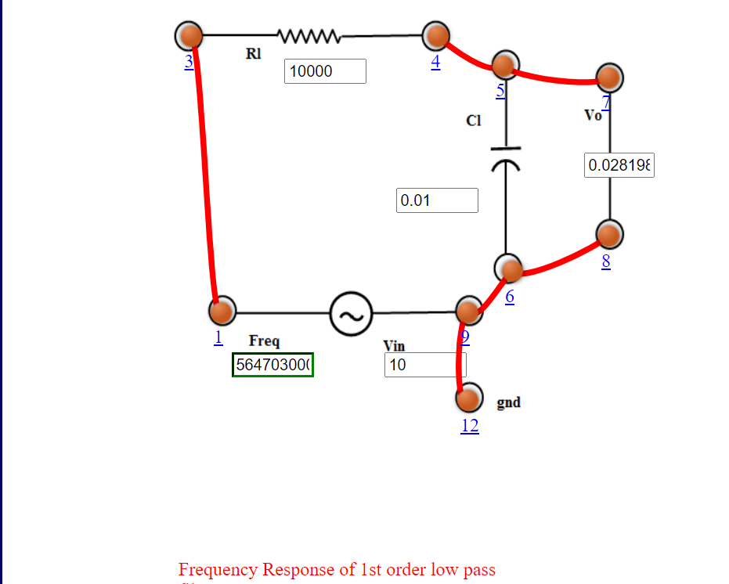

Resistor and capacitor are connected in series and output voltage is taken across the capacitor.

* + **High Pass Filter**

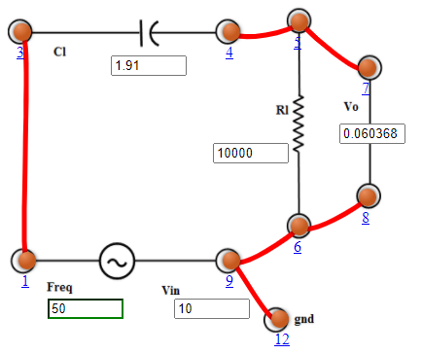

High pass filters are constructed by connecting resistance and capacitor in series and taking output voltage across the resistor.

1. **Measurement Data (Tabular form):**
   * **Low Pass Filter**

|  |  |  |  |  |
| --- | --- | --- | --- | --- |
| Serial No. | Frequency(Hz) | Magnitude(dB) | Phase(theta) | Output Voltage(V) |
| 1 | 50 | -4.33854e-9 | -0.00181185 | 10.000 |
| 2 | 149 | -3.7787200000000004e-8 | -0.00534715 | 10.000 |
| 3 | 438 | -3.29112e-7 | -0.0157806 | 10.000 |
| 4 | 1294 | -0.0000028664399999999996 | -0.0465717 | 10.000 |
| 5 | 3818 | -0.0000249656 | -0.137443 | 10.000 |
| 6 | 11267 | -0.000217436 | -0.405616 | 9.9997 |
| 7 | 33252 | -0.001893432 | -1.19691 | 9.9978 |
| 8 | 98134 | -0.01646342 | -3.52837 | 9.9811 |
| 9 | 289614 | -0.1413372 | -10.3134 | 9.8386 |
| 10 | 854713 | -1.099534 | -28.2394 | 8.8110 |
| 11 | 2522440 | -5.45226 | -57.7660 | 5.3381 |
| 12 | 7444240 | -13.5899 | -77.9657 | 2.0917 |
| 13 | 21969500 | -22.818399999999997 | -85.8980 | 0.72291 |
| 14 | 64836600 | -32.1982 | -88.6381 | 0.24552 |
| 15 | 191346000 | -41.5958 | -89.5686 | 0.083216 |
| 16 | 564703000 | -50.9956 | -89.8840 | 0.028198 |

* + **High Pass filter**

|  |  |  |  |  |
| --- | --- | --- | --- | --- |
| Serial No. | Frequency(Hz) | Magnitude(dB) | Phase(theta) | Output Voltage(V) |
| 1 | 50 | -44.38380000000001 | 89.6996 | 0.060368 |
| 2 | 149 | -34.9852 | 89.0245 | 0.17813 |
| 3 | 438 | -25.5958 | 87.0343 | 0.52507 |
| 4 | 1294 | -16.28706 | 81.2208 | 1.5334 |
| 5 | 3818 | -7.6105599999999995 | 65.4280 | 4.1636 |
| 6 | 11267 | -1.896272 | 36.5171 | 8.0387 |
| 7 | 33252 | -0.26476 | 14.0821 | 9.6998 |
| 8 | 98134 | -0.0312318 | 4.85834 | 9.9641 |
| 9 | 289614 | -0.0035973199999999998 | 1.64972 | 9.9959 |
| 10 | 854713 | -0.000413178 | 0.559134 | 9.9995 |
| 11 | 2522440 | -0.000047441 | 0.189464 | 9.9999 |
| 12 | 7444240 | -0.000005447 | 0.0641992 | 10.000 |
| 13 | 21969500 | -6.254e-7 | 0.0217535 | 10.000 |
| 14 | 64836600 | -7.18056e-8 | 0.00737105 | 10.000 |
| 15 | 191346000 | -8.2444e-9 | 0.00249764 | 10.000 |
| 16 | 564703000 | -9.465819999999999e-10 | 0.000846311 | 10.000 |

1. **Graph (Image/Screenshots)-**
   * **Low Pass Filter**

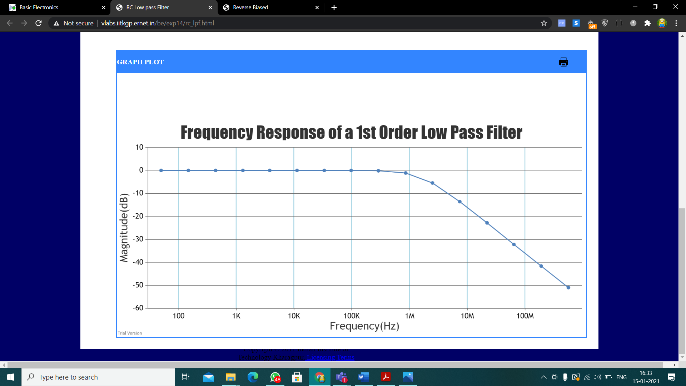

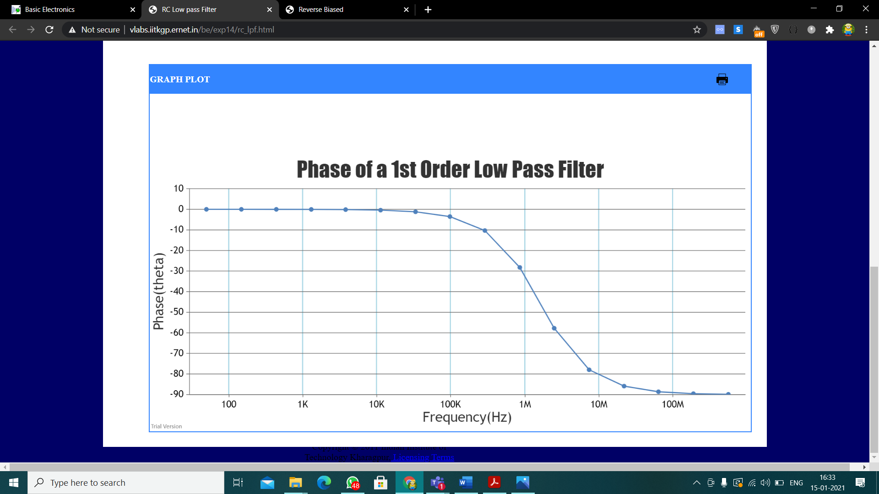

* + **High Pass filter**

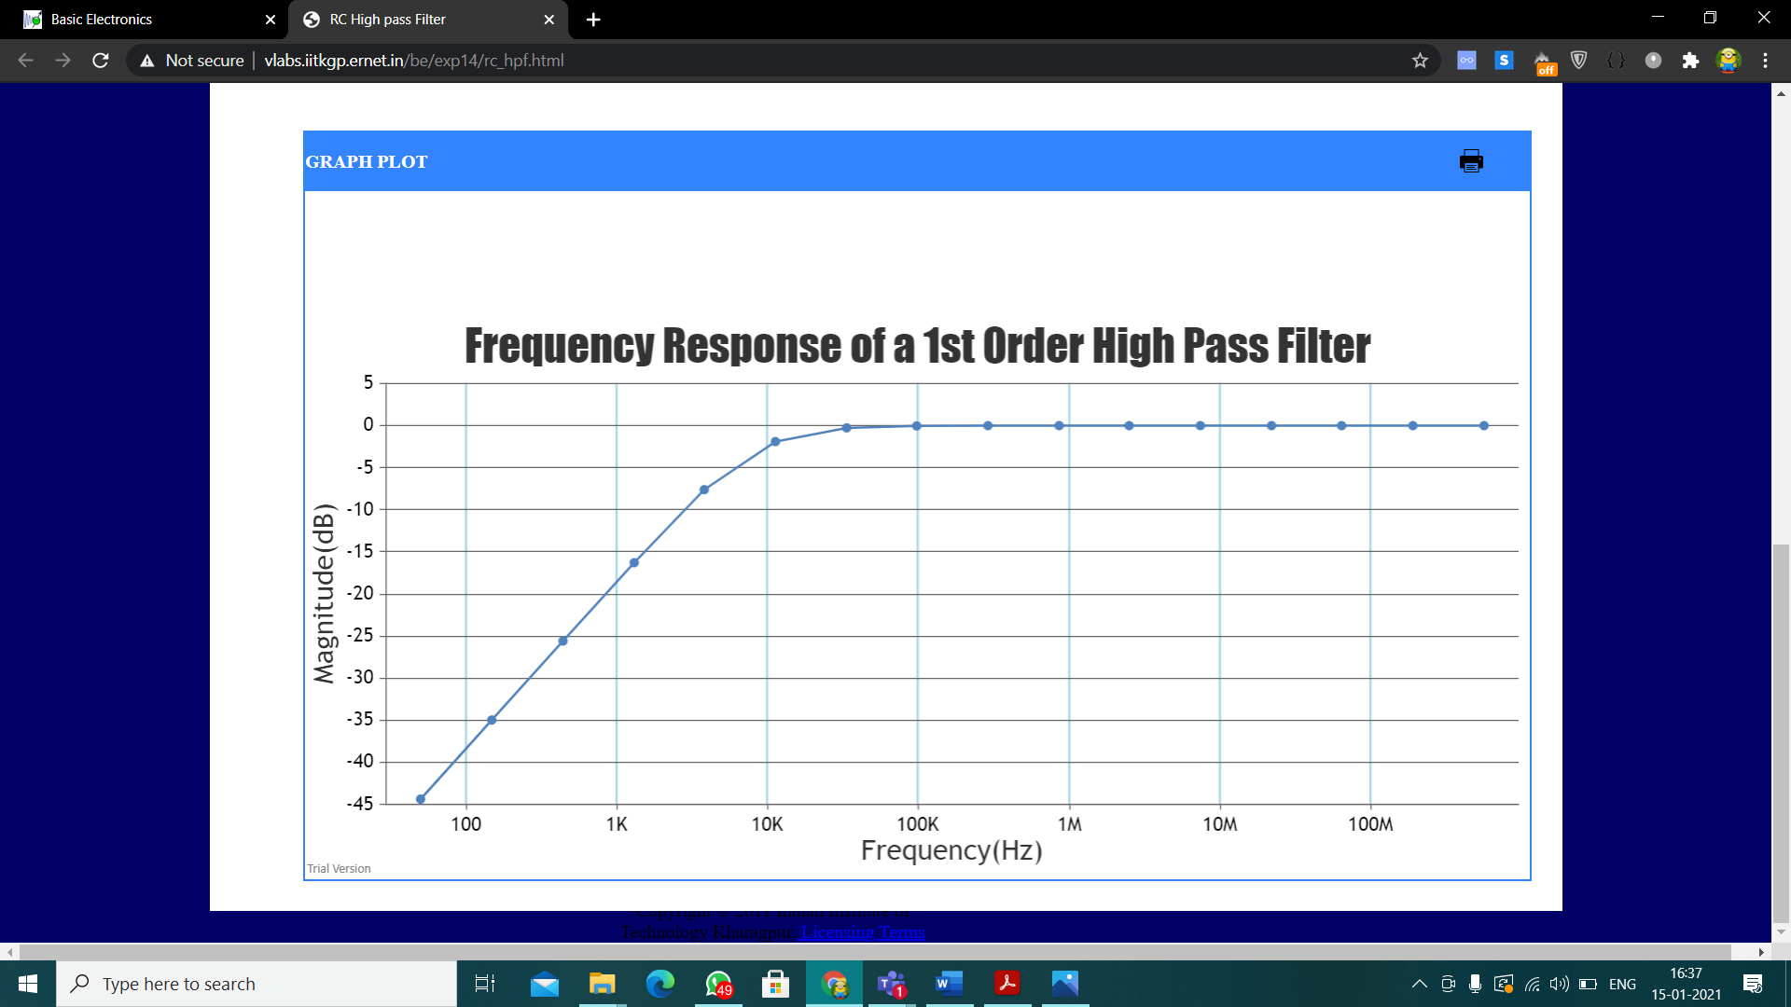

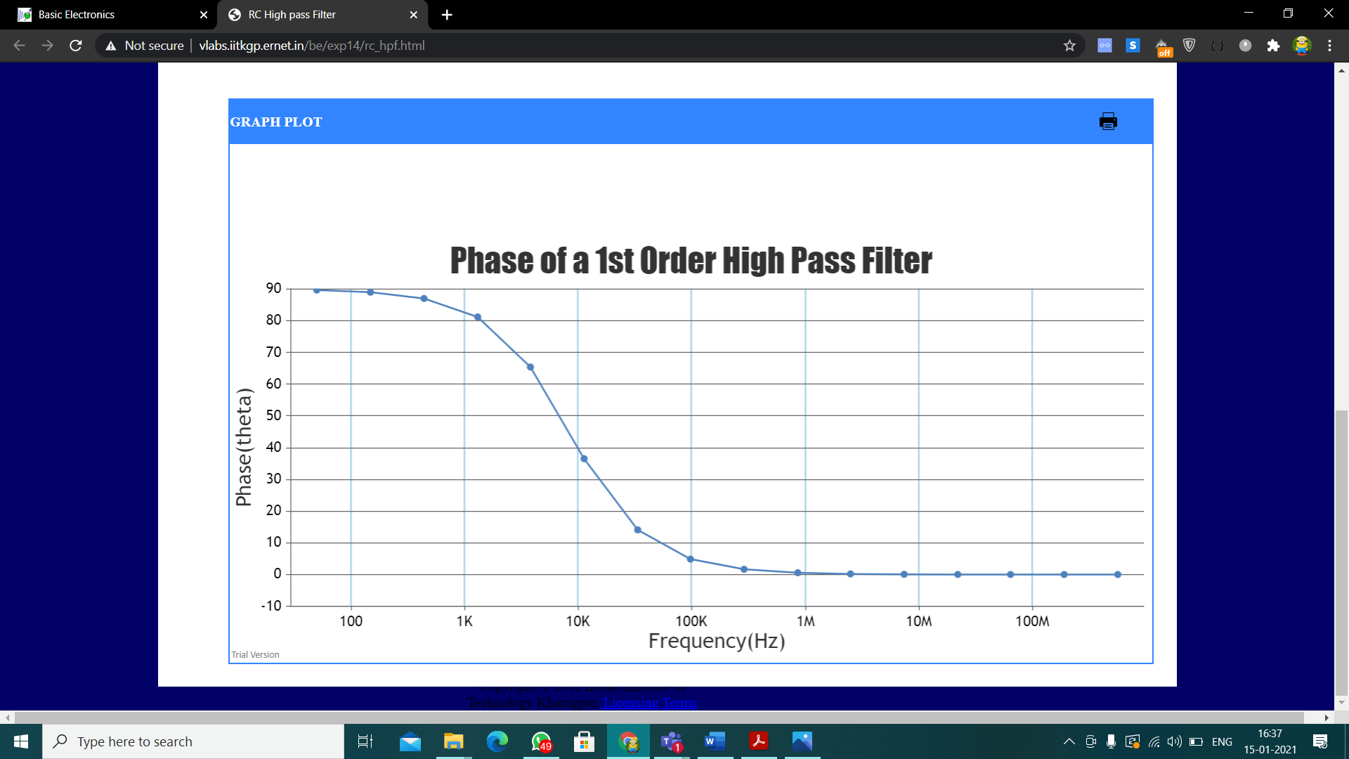

1. **Conclusion:**
   * Low pass filters allow signals of low frequency to pass through and after a certain frequency, higher frequency signals are severely attenuated (Their magnitudes are severely decreased). The frequency at which the output power is reduced to half its input value is called the cut off frequency. It is calculated as fc = ½*pi*R*C.
   * The output signal for LPFs lags in phase.
   * High Pass filters allow signals of high frequency to pass through. Signals of lower frequency are reduced in magnitude. Below a certain frequency the input signals are severely attenuated.
   * Like low pass filters, the frequency at which the output power of high pass filter is reduced to half its input value is calculated as fc = ½*pi*R*C.
2. **Discussions:**
   * Passive filters play a major role in modern electronic circuits. For example, The LPF can be used as an anti-aliasing filter in communication circuits. The HPF can be used in amplifiers like low noise, audio, etc. also, HPF in conjunction with LPF gives rise to a band pass filter which is another important component in circuitry
   * Irrespective of the resistance and capacitance values, in a LPF, in the bandstop region the roll-off rate is fixed : -20 dB/dec. Similarly HPF has a fixed roll-on rate in bandstop region : +20 dB/dec.
   * In LPF, phase shift of the circuit lags behind that of the input signal due to the time required to charge and then discharge the capacitor as the sine wave changes. On the other hand, in HPF, phase shift of the circuit leads than that of the input signal.

**Part 4 : RC Integrator and Differentiator**

1. **Aim of the experiment:**
   * Observing the square wave response of low pass and high pass filters.
   * Explaining and observing RC integrators and differentiators.
2. **Tools used:** 
   * Resistors
   * Capacitors
   * Connecting wires
   * Oscilloscope
   * Multimeter
3. **Background knowledge:**
   * A RC differentiator is a high pass filter. The output waveform of a HPF when a square wave is used as input looks like the mathematical form of differentiation hence it is named so.
   * A RC integrator is a low pass filter. The output waveform of a LPF when a square wave is applied to it looks like the mathematical form of integration and hence it is named so.
4. **Circuit / Oscilloscope(hand drawn/image):**
   * **RC integrator**

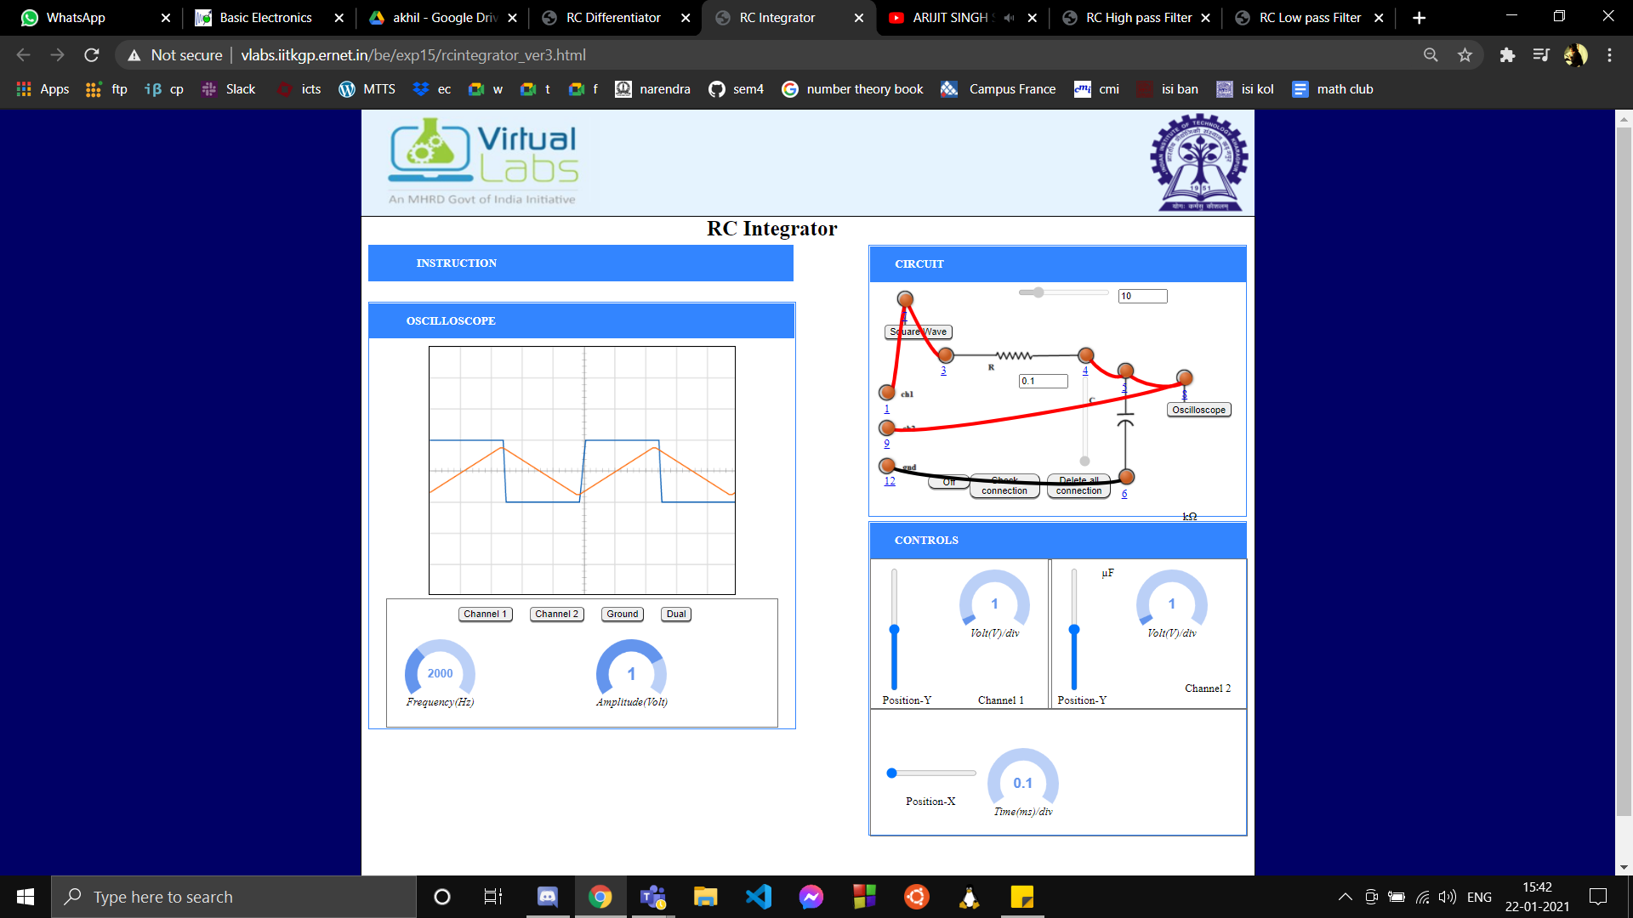

Here we can see the output waveform of an RC integrator when a square wave is applied to it, we can also observe how the output waveform corresponds to integration of the input waveform because of its shape.

* + **RC Differentiator:**

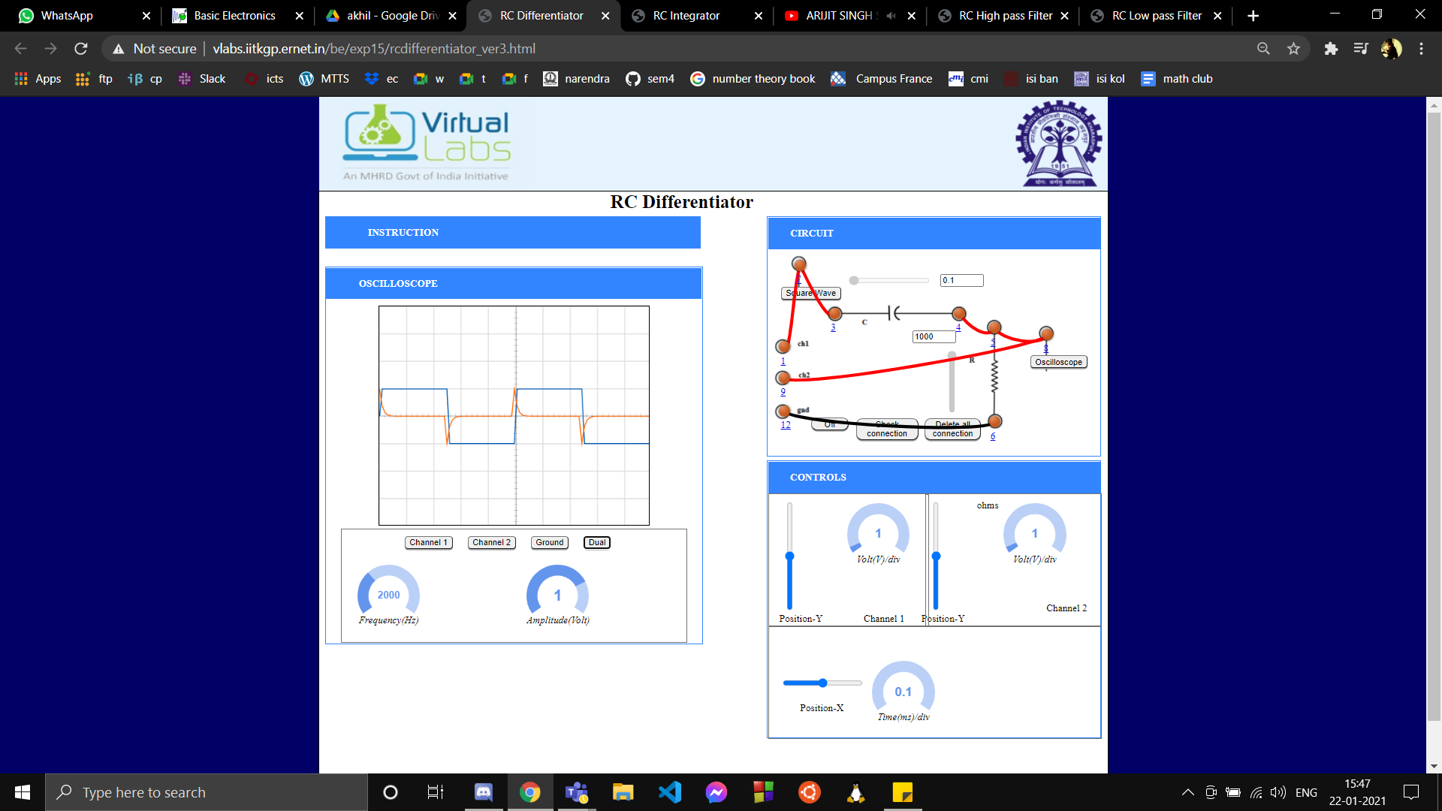

Here we can observe the output waveform of the RC differentiator and how it corresponds to mathematical process of differentiation

1. **Conclusion:**
   * In conclusion we can say when a square wave is applied to a low pass or high pass filter we expect the output waveform to look a certain way for a specific filter.
   * For a high pass filter the output waveform looks like the differentiation of the input waveform and hence it is called the RC Differentiator
   * For a low pass filter the output waveform looks like the integration of the input waveform and hence it is called the RC integrator.
2. **Discussions:**
   * While conducting the RC integrator and differentiator experiments practically, an oscilloscope is used to view the output waveforms. An oscilloscope is a type of electronic test instrument that graphically displays varying signal voltages, usually as a calibrated two-dimensional plot of one or more signals as a function of time. The displayed waveform can then be analyzed for properties such as amplitude, frequency, rise time, time interval, distortion, and others.
   * After adjusting the oscilloscope parameters we clearly saw the various output waveforms. It was crucial to have a certain frequency of the input square waveform in order to clearly see the output. We found this range by trial and error.